4-H Online 2.0 Animal Entry Guide
BOULDER COUNTY- Beef Projects (Breeding Beef and Dairy Cow)

- Deadline the last Thursday In April annually
*Note: For 4-H Members 8 and above

Gather the following items for your Animals:
- Two Photos- Right Side profile, Left Side profile- JPEG
- Brand Inspection in your name- PDF File
- Premise ID where your animal is kept
- Lease Agreement- Required for Dairy Cattle- PDF
- Identifying information including, name, tag, registration numbers, birthdate, etc.
- County Use form- Not needed for Boulder County

Bill of Sale- not required for BOCO unless it has the brand inspection on it

Log into 4-H Online

- Your family email and password https://V2.4HOnline.com

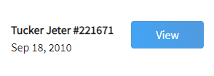
Click “View”, next to Member’s Name

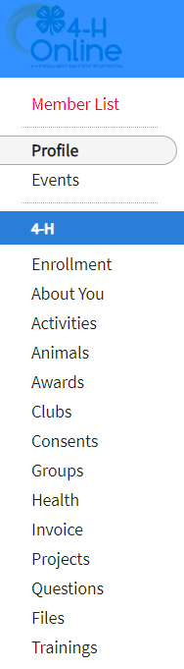
Locating ‘Animals’

- Desktop, select “Animals”
from the left side navigation

- Smart Phone or Tablet, click on the 3 bars in the top left corner
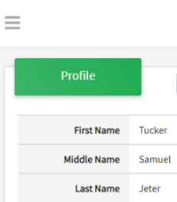
With either option, this will bring up a drop down list to begin adding Animals.

Adding an Animal
- Click "Add an Animal" 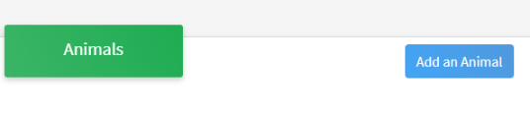
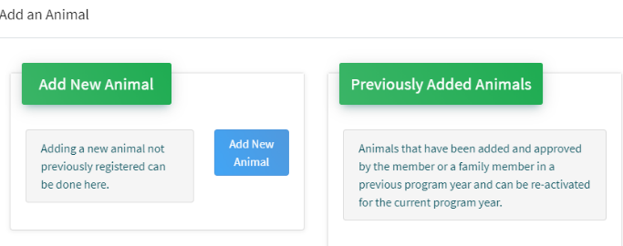Then select “Add New Animal”
- Select Beef Breeding or Dairy Cow, from the drop down.
REQUIRED: Enter Tag Number. NOTE: If animal does not have a county tag enter 000.
Click “Save”
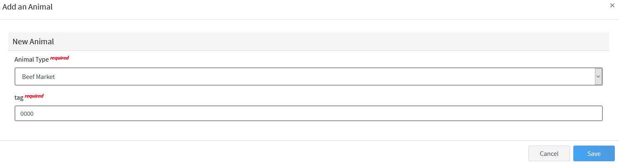

- Next, click “Show Questions” – NOTE: Check county requirements and complete accordingly.
Animal Entry is open for the current enrollment year. - Is all information complete? Check all county animal entry deadlines.
READ All County instructions for each animal species as county requirements vary.
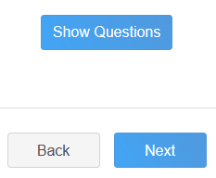
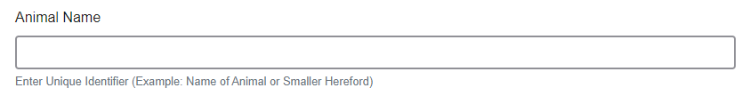
- Enter the animals name or other unique identifier, in the case of no tag number. This information will assist County Staff using the FairEntry or other system for County Fairs.

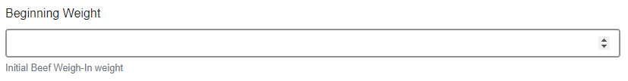
- Enter the beginning weight of the animal. If this Market Beef or Breeding Beef was weighed in at an official tag in/weigh in use that weight, otherwise use the weight of the animal at the time you purchased or if home-raised, when it was born.

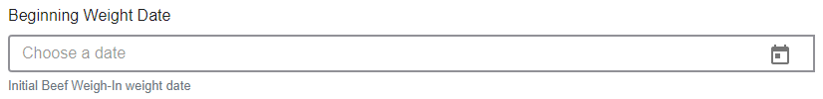
- Choose the date of the beginning weight entered above

- Choose the breed from the drop down box. Choose *Other/Cross Breed or Mixed Breed. You can only choose one breed
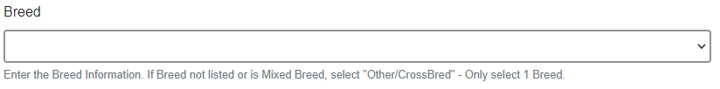

- Add Premises ID or Location ID,this is needed for Boulder County Fair.
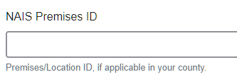
- Select the animal gender from the drop down box. Steers will need to be put under male.
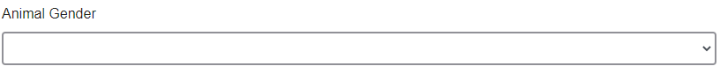
- The tag number entered on the first screen will carry over to this screen. Please verify that they tag number is correct for the animal entered above. 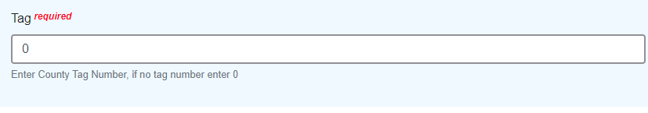
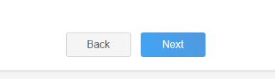
- Click “Next”, continue with the “File Uploads” that are required Please follow your county guidelines (Boulder County needs these items for beef projects: )
  - 2 side profile photos needed
  - County Use form (https://boulder.extension.colostate.edu/4h/animalid/)
  - Brand inspection paperwork- in the members name
  - Breed verification form if purebred
  - Registration paperwork if applicable
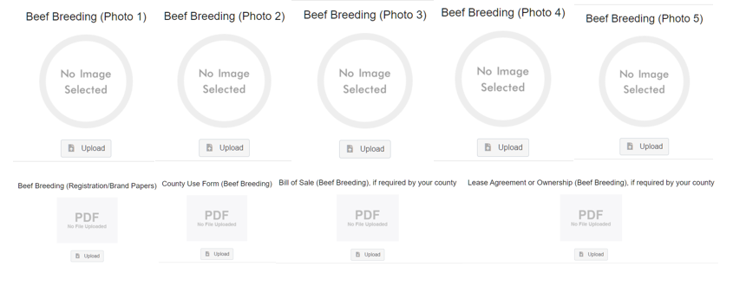

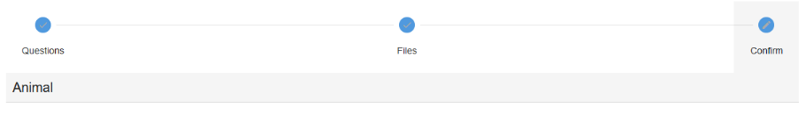
- Confirm all information, click ‘submit’

- County Extention staff, will review all information. If more is needed, members can edit. Once “Approved” by your local county extension office an email will be sent to your family account (example below) A time and date stamp for each animal.
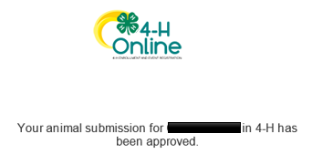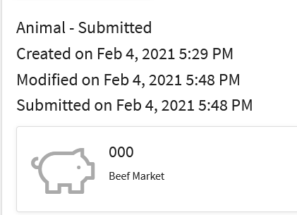

- Questions, please contact the Boulder County 4-H Office staff,
Lisa Wallace, lwallace@bouldercounty.org.

