4-H Online 2.0 Animal Entry Guide
Boulder 4-H Rabbit Projects (Breeding, Companion/Pet)

- Deadline the last Thursday in April annually
*Note: For 4-H Members 8 and above

Gather the following items for your Animals:
- Two Photos- Right Side profile, Left Side profile- JPEG
- Premise ID where your animal is kept
- Boulder County – County Use form for Rabbits – Completed and PDF
- Identifying information including, name, tattoo, birthdate, breed, etc.
  - For Tattoo- type PENDING if you don’t have one yet. Once you do have the tattoo- please send the update to lwallace@bouldercounty.org

Log into 4-H Online

- Use your family email and password https://V2.4HOnline.com

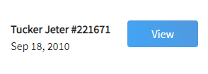
Click “View”, next to Member’s Name

Locating ‘Animals’

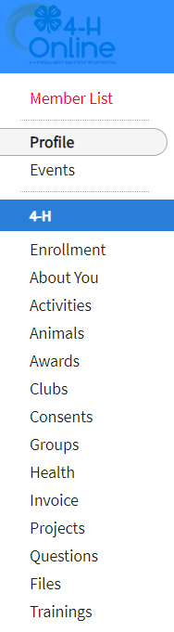
- Desktop, select “Animals” from the left side navigation

- Smart Phone or Tablet, click on the 3 bars in the top left corner
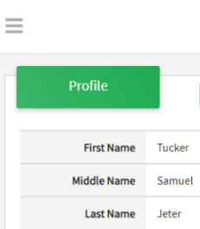
With either option, this will bring up a drop down list to begin adding Animals.

Adding an Animal
- Click "Add an Animal" 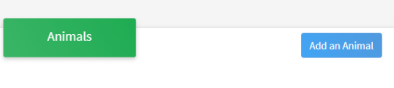
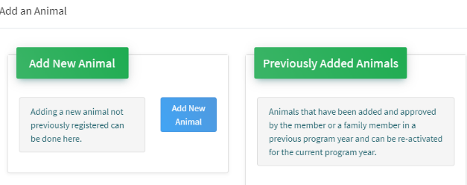Then select “Add New Animal”
- Select Rabbit Breeding (If you have a purebred animal, you are in this project)
- Rabbit Market -DO NOT ID ANIMALS THIS WAY
- Rabbit Pet (if you have a mixed breed animal and are in companion animal project)
- from the drop down. REQUIRED: Enter Tag OR Tattoo Number. NOTE: Required Field is different between breeding or market animals. If an animal does not a county number enter 000. Click “Save”
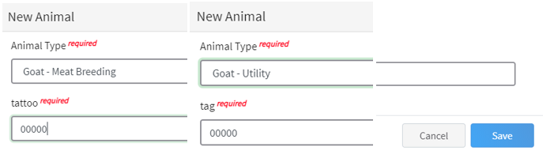
- Next, click “Show Questions”
Animal Entry is open for the current enrollment year. - Is all information complete? Check all county animal entry deadlines.
READ All County instructions for each animal species as county requirements vary.
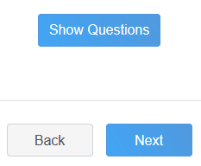

- For Rabbit complete each of the sections . 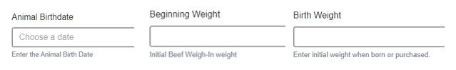
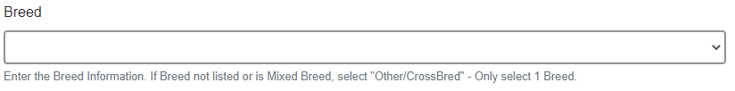
- Choose the breed from the drop down box. Choose *Other/Cross Breed or Mixed Breed. You can only choose one breed.

- Enter any distinguishing colors or markings. (Enter variety, Ex: Solid, Broken, Black, Blue, etc):
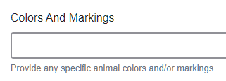
- Add Premises ID or Location ID, as this is needed for the Boulder County Fair- Please complete.
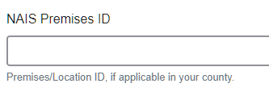

- Select the animal gender from the drop down box.
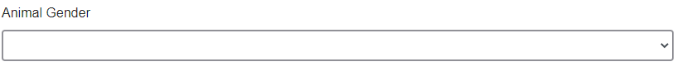


- The tag OR tattoo number entered on the first screen will carry over to this screen. Please verify that they tag number is correct for the animal entered above.
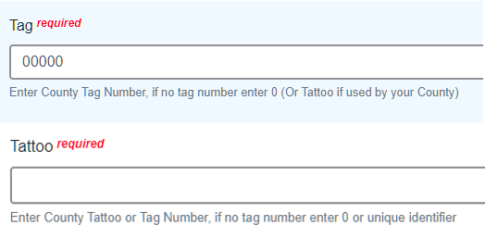

TAG( is actually the tattoo number again): type PENDING if you don’t have one yet. Once you do have the tattoo- please send the update to lwallace@bouldercounty.org
Tattoo( same as tag): type PENDING if you don’t have one yet. Once you do have the tattoo- please send the update to lwallace@bouldercounty.org

- Click “Next”, continue with the “File Uploads” that are required by your county. Boulder County needs two photos of your rabbits- one of each side profile- left and right side. Up to 6 photos can be added per rabbit. 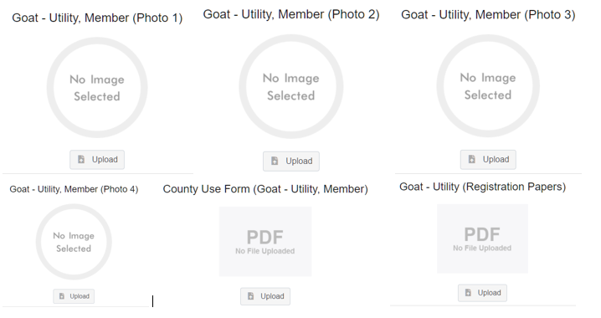
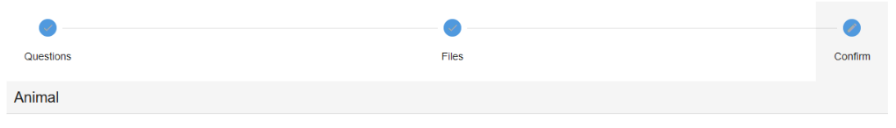
- Confirm all information,
Click ‘submit’

- County Extention staff, will review all information. If more is needed, members can edit. Once “Approved” by your local county extension office an email will be sent to your family account (example below) A time and date stamp for each animal.
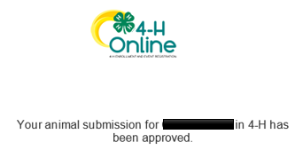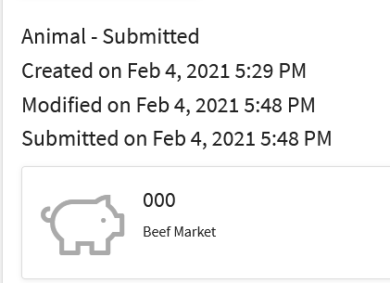

- Questions, please contact the Boulder County 4-H Office staff,
Lisa Wallace, lwallace@bouldercounty.org.

