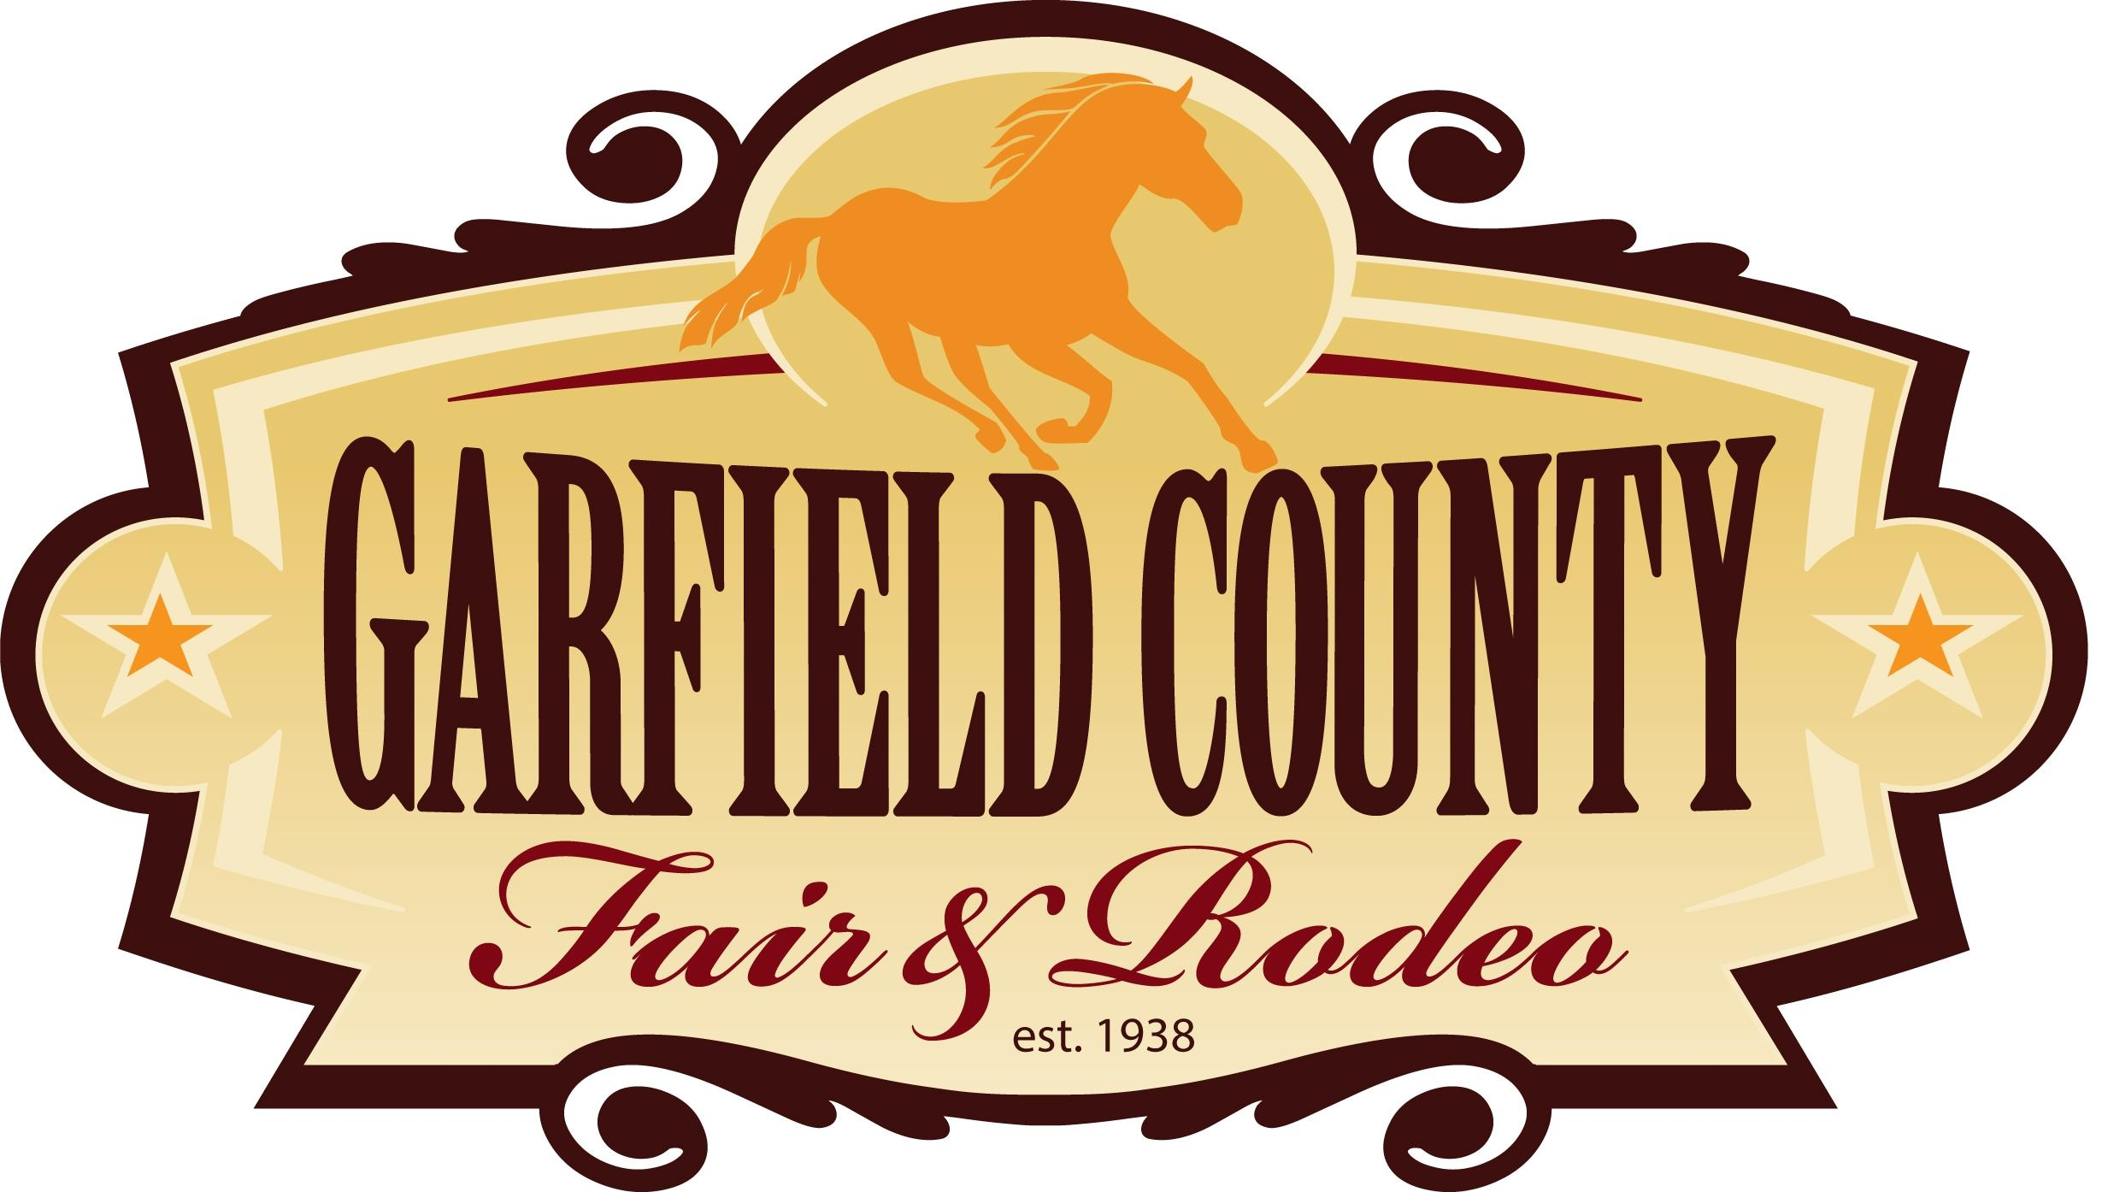

GARFIELD COUNTY FAIR HORSE SHOW

Guidebook



Safety Disclaimer

By holding or participating in a 4-H Horse Ride/ Practice, you voluntarily ACCEPT AND ACKNOWLEDGE THAT HORSEBACK RIDING IS AN INHERENTLY DANGEROUS ACTIVITY AND INVOLVES RISKS THAT MAY CAUSE SERIOUS INJURY AND IN SOME CASES DEATH, because of the unpredictable nature and irrational behavior of horses, regardless of their training and past performance.

These risks include that a horse or may, without warning or any apparent cause, buck, stumble, fall, rear, bite, kick, run, make unpredictable movements, spook, jump obstacles, step on a person’s feet, push or shove a person, saddles or bridles may loosen or break- all of which may cause the rider to fall or be jolted, resulting in serious injury or death.

By holding or participating in a 4-H Horse Ride/ Practice, you understand, accept, and assume all such hazards and risks, and waive all claims against Garfield County, Colorado 4-H Foundation, State of Colorado, The Board of Governors of the Colorado State University System, and Colorado State University.

Leaders holding practices are required to fill out an incident report for any out-of-the-ordinary occurrences including but not limited to a rider falling off their horse, a rider being kicked by or bucked off of their horse, and injuries to participating leaders or members that do not involve an animal but occur during the 4-H event.

Leaders who choose to hold practices off the Garfield County Fairgrounds Campus are required to fill out and submit and event plan to the 4-H Agent for approval.

HORSE SHOW RULES

- For specific rules, the Colorado 4-H Horse Show Rulebook.
- Exhibitors must be properly enrolled in the 4-H/FFA Horse project and must be a member in good standing within their club or chapter.
- Online entries for exhibiting at the Garfield County Fair are due through FairEntry.com by 5 pm on July 1st. NO LATE ENTRIES WILL BE ACCEPTED!
- An exhibitor may exhibit only one horse in any class.
- All equines must be free of visual evidence of the following diseases and conditions: mange, ringworm, strangles, open or draining wounds. A licensed veterinarian may be present on the grounds to visually inspect horses for signs of VS at the discretion of the Horse Committee.
- All exhibitors must have participated in 5 riding practices with an approved 4-H Horse Leader by June 1st.
- Definition of an approved 4-H Horse Leader – To become approved, horse leaders must attend Rater Training, Horse Leader Training, or present experience in training horses and/or riders to the 4-H agent before holding a practice.
- LEVELS TEST REQUIREMENTS:
  - Safety tests must be complete by April 15th
  - All written tests must be completed by May 15th
  - All riding tests must be complete by June 1st
4-H/FFA members must have completed and passed the appropriate written and riding levels test to compete in specific classes.
- AGE DIVISIONS: Classes are determined by the age of the exhibitor as of December 31st of the previous year.
Seniors: 14 & Over Intermediates 11-13 Years Juniors: 8-10 Years
Novice: Any age (Walk / Trot ONLY)
To exhibit at Fair, all Novice riders must have passed their Safety Test before the April 15th (Novice riders will only exhibit using walk/trot).
- Novice Division exhibitors are limited to entering in Written Test, Novice Western Showmanship, Novice Western Pleasure, Novice Western Horsemanship, Novice Trail, , Novice English Showmanship, Novice Hunter Under Saddle, Novice English Equitation.

- Project Completion and Requirement for Fair Participation: To complete the 4-H Horse Project, members are required to:
  - Attend 50% of their club meetings to be a Garfield County 4-H member in good standing.
  - Attend 5 practices with an approved 4-H horse leader who has received authorization from the 4-H agent to hold practices.
  - Complete a 4-H Horse Record Book on all horse project animals.
  - Give a demonstration at the club level.
  - Exhibit their project by participating in a Western or English showmanship class at the Garfield County Fair or showmanship at a 4-H Sanctioned Horse Show, or other events with prior approval from the Garfield County 4-H Horse Advisory Committee (HAC) (Garfield County Fair, NW Colo Expo, District Show, or Colorado State Fair).
  - Participate in a Community Service Project.

- Points for High Point awards are calculated on a one horse/one youth basis per discipline. Score cards will be used to calculate placing for all classes and divisions in Western, English, Ranch and Working Western. For timed events, all participants in each event will be awarded points in accordance to their time. Age division placings will be awarded separately within each division and event. Participants will be given a score as follows:

1st place: 100 points
2nd place: 95 points
3rd place: 90 points
4th place: 85 points
5th place: 80 points
6th place: 75 points
7th place: 70 points
8th place: 65 points
9th place: 60 points
10th place: 55 points
11th place: 50 points
12th place: 45 points
13th place: 40 points
14th place: 35 points
15th place: 30 points

- HORSE PROJECT AWARDS:
Awarded at Achievement Night:

- Overall Supreme Exhibitor & Reserve Overall Supreme Exhibitor – awarded to the highest scores out of all the age divisions. The total of all scores in all classes, written test, and record book will be totaled.
- Premier Exhibitor & Reserve Premier Exhibitor - awards will be offered in each age division (Jr, Sr, & Novice). The total of all scores in all classes, written test, and record book will be totaled.

Awarded at the Garfield County Horse Show:

- High Point Western Exhibitor – Champion and Reserve Champion ribbons will be offered in each age division (Jr, Sr). All Western Classes and the written test, except for the Colt project, will count towards the Western High Point award.
- High Point Western Exhibitor - Novice - Champion and Reserve Champion ribbons will be offered based on Novice classes.
- Grand Champion Western (Buckle) and Reserve Grand Champion Western – awarded to the highest scorers of the High Point Western Champion and Reserve Champion Exhibitor winners.

- High Point English Exhibitor – Champion and Reserve Champion ribbons will be offered in each age division (Jr, Sr). All English classes and the written test will count towards the English High Point award.
- High Point English Exhibitor - Novice – Champion and Reserve Champion ribbons will be offered based on all English Novice classes.
- Grand Champion English (Buckle) and Reserve Grand Champion English – awarded to the highest scorers of the High Point English Champion and Reserve Champion Exhibitor winners.
There must be a minimum of four (4) entries in either the Novice English or Novice Western for separate awards to be offered.

- High Point Gymkhana Exhibitor – Champion and Reserve Champion ribbons will be offered in each age division (Jr, Sr). All Gymkhana Classes and the written test will count towards the Gymkhana High Point award.
- Grand Champion Gymkhana (Buckle) and Reserve Grand Champion Gymkhana – awarded to the lowest combined times of all age divisions. Scores will be awarded as stated in Rule 13, for combined times.

- High Point Ranch Horse Exhibitor – Champion and Reserve Champion ribbons will be offered in each age division (Jr, Sr). All Ranch Horse classes, and the written test will count towards the Ranch Horse High Point award.
- Grand Champion Ranch Horse (Buckle) and Reserve Grand Champion Ranch Horse – awarded to the highest scorers of the High Point Ranch Horse Champion and Reserve Champion Exhibitor winners.

- High Point Working Western Horse Exhibitor – Champion and Reserve Champion ribbons will be offered in each age division (Jr, Sr). All Working Western Horse classes, and the written test will count towards the Working Western Horse High Point award.
- Grand Champion Working Western Horse (Buckle) and Reserve Grand Champion Working Western Horse – awarded to the highest scorers of the High Point Working Western Horse Champion and Reserve Champion Exhibitor winners.

In the event of a tie, written test score will be used. There will be a separate test for each division (Western, English, Gymkhana, Ranch, and Working Western) and each age division (Jr, Sr) and a tie-breaker question. You can choose not to take a test, but you will not be considered for Overall & Reserve Overall Exhibitor, Premier & Reserve Premier Exhibitor, or Grand & Reserve Grand Champion awards.

- White Ribbon Record Books are NOT eligible to receive achievement awards. Youth receiving a white ribbon record book are required to meet with the 4-H Agent to review and correct by December 1st to be eligible to participation in the Horse project.
- No adults are to be mounted, warming up, exercising, or training any project horse for an exhibitor at the Garfield County Fair. Infraction of this rule could lead to disqualification of the exhibitor from classes following the infraction.
- Exhibitors may use the warm-up area and outside arena (when no classes are being held).
- Excessive coaching is discouraged, and rider will be penalized by the judge.
- Classes may be combined if the number of entries so warrant. If this occurs, points will be awarded to the exhibitor in their appropriate age division.
- It is the exhibitor’s responsibility to declare in written form, any veterinarian’s prescribed medication to the Horse Committee prior to the beginning of the show.
- Only wood shavings, sawdust, sand and/or rubber mats are allowed for bedding in the horse stalls. NO STRAW or SHREDDED PAPER is allowed.
- DISPLAY CLASS for those unable to exhibit a horse, as well as those wishing to exhibit a display during Fair, please enter the “Display Class”. Displays should be brought to the Extension Office prior to the start of the Garfield County Fair.

LIVESTOCK ROUND ROBIN SHOWMANSHIP CONTEST
Junior, Intermediate, and Senior Championship awards
Contest: Friday after Beef Show

GENERAL RULES:
- The Round Robin Showmanship Contest is open only to members in good standing in 4-H/FFA in Garfield County. Beef, Sheep, Swine, Goat, Rabbit, Poultry and Horse will be the species included in the Round Robin Contest. There must be five of a species entered before it can compete in Round Robin.
- Members must be enrolled in any of the following projects to participate in the contest: Beef, Sheep, Swine, Goat, Rabbit, Poultry or Horse.
- The 1st and 2nd place showmen in 4-H Western Showmanship (English Showmanship will be used if necessary) in each age group (Jr, Int, Sr) will be required to compete in the Livestock Round Robin Showmanship Contest. If the 1st or 2nd showman for horse is unable to show due to showing for another species, then the next highest placing competitor will be required to compete in the Round Robin Contest.
- In the case of a tie in the Round Robin judging, the tiebreaker will be the contestant having the highest grooming score on his or her animal.
- Members must show their own animal for the species they qualify with.
- Preparation of the animal for show and all grooming must be done by the 4-H/FFA member. Parents and leaders are encouraged to help members with their animal with the consideration that Fair is a learning experience for the member. Any assistance given should not be excessive. No outside help will be permitted, including members not enrolled in Garfield County. Anyone excessively assisting a member may be asked to leave the premises by the Superintendent of any species, FFA Advisor, or Extension Agent. Superintendents will supervise the Round Robin show of their assigned species and help to ensure the safety of members and animals.

